- Execute and display the results for the following commands in Kali Linux Operating
Systems:

rm command
users command
tree command

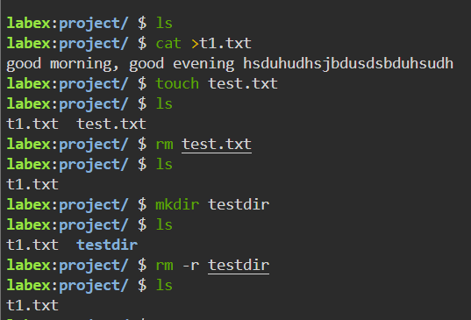

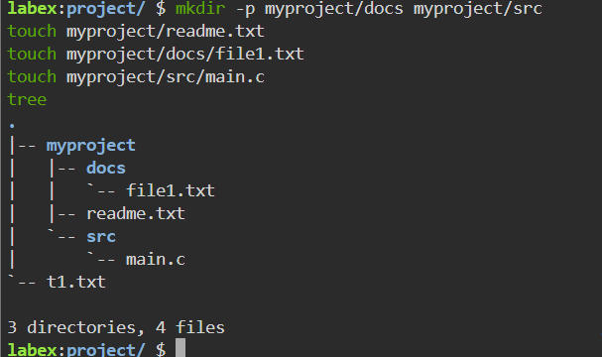

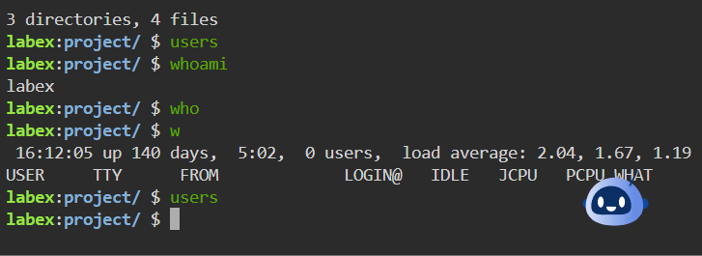

2. Execute and display the results for the following commands in Kali Linux Operating
Systems:

less command
more command
vi command

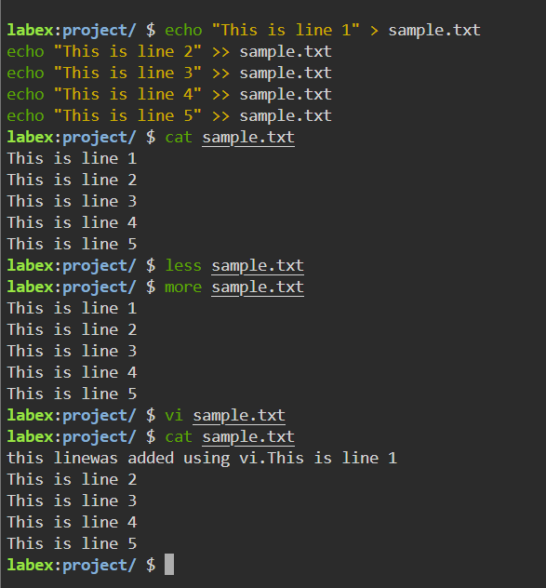

3.Execute and display the results for the following commands in Kali Linux Operating
Systems:

Tree
Head
Tail

